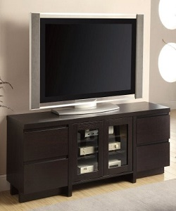

TV Stand

$45.75

Availability: In stock

Description

The light and fresh design, tapered legs, for storage and TV. This collection create a stylish look that embraces vintage flair and modern living. Complete your living room decor with Style options. Walnut Black wood finish.